IMPACT OF COVID-19 PANDEMIC IN NIGERIA

**INTRODUCTION**

Coronavirus disease (COVID-19) is an infectious disease caused by a newly discovered Virus called Corona Virus. The virus was first discovered in China where the first case was recorded before it began to spread to other countries. This virus has led to death of millions of people all over the world, it has also affected the economic condition of all countries. The adverse effect of Covid-19 pandemic in the world cannot be overemphasized.

The effect of the virus was also discovered in Nigeria, a West-African country with 37 states and a fast-growing economic environment with about 200 million citizens. The first case was recorded on 27th February 2020 followed by other numerous cases which increased rapidly after few months. Some of the effect of Covid-19 in Nigeria include:

* Shutting down of major Airports.
* Nationwide lockdown and curfews
* Closure of schools and Institutions
* Closure of Financial Institutions

**OBJECTIVE**

The main objective of this research is to determine the impact of the covid-19 pandemic across all the 37 states in Nigeria.

* To determine the impact of covid-19 across the 37 states of the country.
* To determine the daily trend and infection rate across all the 37 states in the country since it first cases on 27th February 2020
* To determine the factors responsible for the increase in confirmed cases and death cases in the country.
* To determine how covid-19 pandemic affected the economy of the country.

**RESEARCH QUESTIONS**

The research is set to answer the following questions:

* What is the impact of covid-19 across the 37 states of the country in terms of daily confirmed cases and death cases?
* What is the daily trend and the infection rate across all the 37 states in the country since its first case on 27th February 2020?
* What are the factors responsible for the increase in confirmed cases and death cases in the country?
* In what way has the covid-19 pandemic affected the economy of the country?

**DATA COLLECTION**

The data used were collected from 4 different sources which include the following;

* Nigeria Centre for Diseases Control (NCDC)
* Johns Hopkins University Center for Systems Science and Engineering (JHU CSSE)
* Nigeria Community Vulnerability Index data
* Real Domestic Gross Product Data and State Budget Data

The data collection process and sources are different for all the data used for the analysis;

* Nigeria Centre for Diseases Control (NCDC) monitors the country’s COVID-19 situation and releases data on metrics across all the 37 states in the country.

Data from NCDC was collected through NCDC COVID-19 [official website](https://covid19.ncdc.gov.ng/) which contain information about the total confirmed cases, death cases, and recovery cases of the covid-19 pandemic across all states in Nigeria. The data was obtained by performing web scraping on the official website, which was cleaned and saved in CSV formatted file.

* Johns Hopkins University Center for Systems Science and Engineering (JHU CSSE) publishes daily data on confirmed, death, and recovered cases for different countries. The daily data for Nigeria was accessed and was downloaded in a CSV format from their repository
* Nigeria Community Vulnerability Index data  
  The vulnerability index was computed by considering several factors such as socioeconomic status, population density, housing type, transportation, epidemiological, health system, etc. These factors are known as themes. Each theme was broken into subthemes, and data was gathered to compute the overall vulnerability index score by weighing each theme equally.

**Note that:** The term “vulnerability” refers to the impact of the virus on a community after the virus arrives. It ranks from Very Low (0) to Very High (1+)

* Real Domestic Gross Product Data and State Budget Data  
  This contains information about the quarterly Real Domestic Gross Product (GDP) data for Nigeria pre-covid-19 and post covid-19. The state budget contains information about the state budget across the 37 states of the country pre and post covid-19 pandemic.

The dataset was collected, cleaned and transformed into the appropriate format for the analysis using Pandas and Numpy which was then visualized using Seaborne and matplotlib. Below are the insight got from the analysis.

**OBJECTIVE 1**: The impact of covid-19 across the states of the country

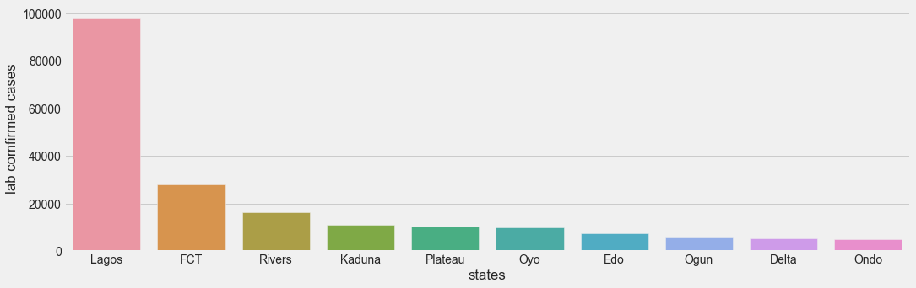

Fig. 1: Plot showing the daily cases of covid-19 across the 37 states

The above chart shows the top ten states with the highest number of covid-19 confirmed cases with Lagos and FCT being the first and second states respectively and Delta and Ondo being the ninth and tenth states.

Based on the above chart, it could be deduced that Lagos had the highest number of covid-19 cases.

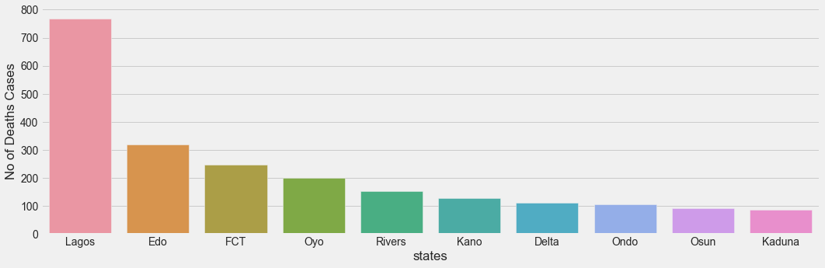

Fig. 2: Plot showing the death cases of covid-19 across the 37 states

The above chart shows the top ten states with the highest number of covid-19 Death cases with Lagos recording the highest number of death cases followed by Edo and Osun and Kaduna with least cases among the 10states above

**OBJECTIVE 2**: The daily trend and infection rate of covid-19 across the country

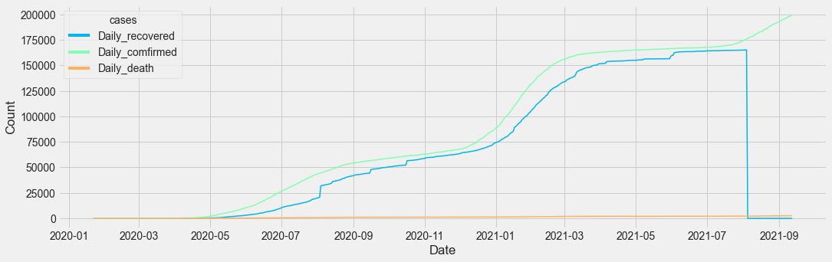

Fig. 3: Plot showing the daily trend of covid-19 cases across the 37 states

The chart above shows the daily trend over time in the number of confirmed cases, recovered cases and death cases, this shows a higher proportion in the number of confirmed cases compared to recovered cases and death cases, with each spike in the confirmed cases indicating the beginning of a new covid-19 phase.

This shows

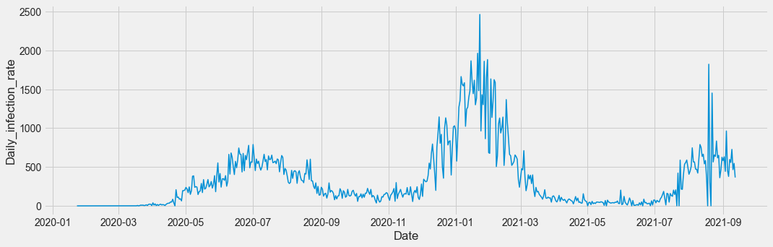

Fig. 4: Plot showing the infection rate across the 37 states

The chart above shows the daily infection rate of covid-19 across the 37 states, with the maximum daily infection rate of 2464 cases on the 23rd of January 2021

**OBJECTIVE 3**: Factors responsible for the increase in confirmed cases

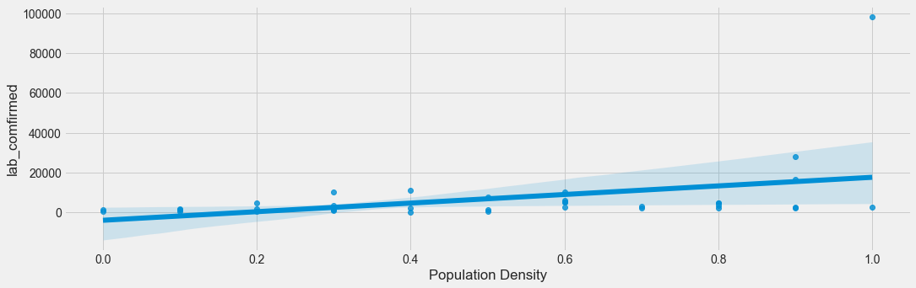

Fig 5: Effect of Population Density on Covid-19 Pandemic

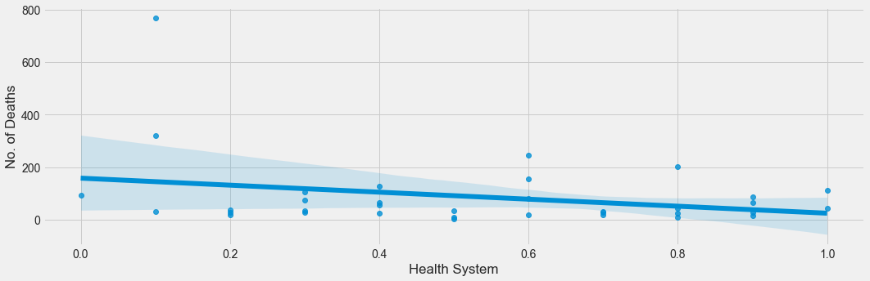

Fig 6: Effect of Health System on Covid-19 Pandemic

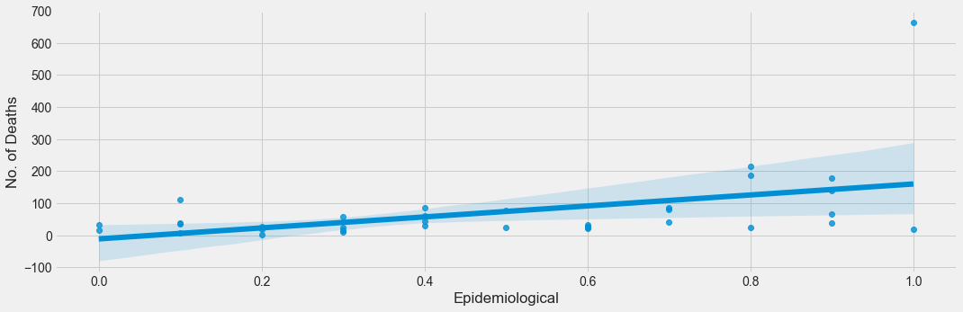

Fig 7: Effect of Epidemiology on Covid-19 Pandemic

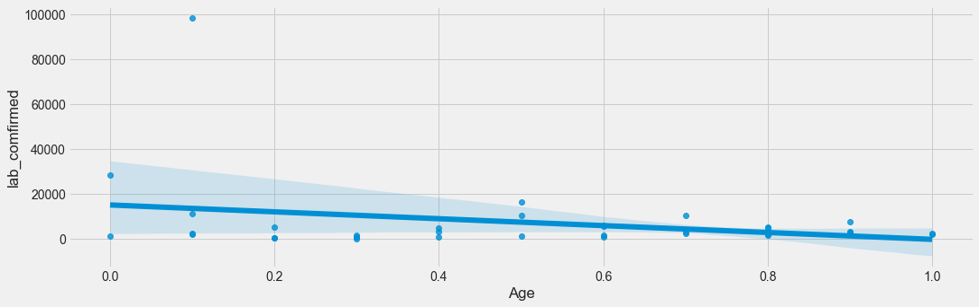

Fig 8: Effect of Age on Covid-19 Pandemic

The charts above show some of the factors that affect the spread of covid-19 cases in Nigeria. Factors such as population density, Epidemiology, and Age has a positive correlation with increase in spread of covid-19 cases while factors such as health system, socioeconomic, and fragility has a negative correlation with the number of death and confirmed cases

**OBJECTIVE 4**: In what way has the covid-19 pandemic affected the economy of the country

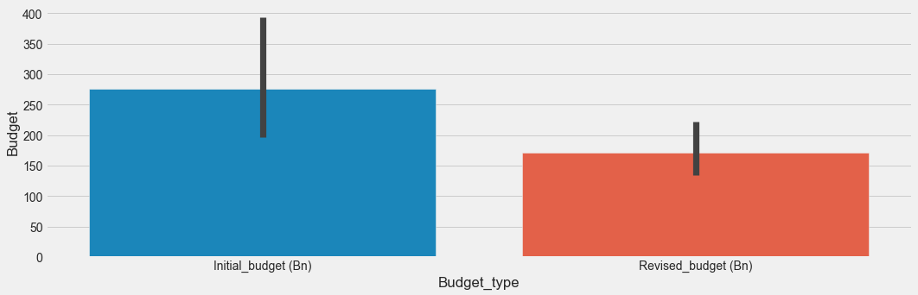

Fig Plot showing the total budget pre_covid-19 and post-covid-19

The economy is measured in terms of real GDP and Budget, the effect of a covid-19 pandemic on the economy is determined by its effect on the real GDP and the country’s Budget.

The chart above shows the total budget of the country pre-covid-19(initial budget) and post covid-19(Revised budget), with a difference of 105.13 billion.

The pandemic threw the country’s economies into disarray by causing a shortfall in the initial budget due to the loss of revenue necessary for public expenditure. A large proportion of the revenue resources were paralyzed by the effect of the pandemic and also a large sum of the government budget was reappropriated to deal with the immediate consequences of the pandemic putting a crunch on the remaining fiscal resources.

Conclusion

In Conclusion, the most affected state in terms of confirmed cases and death cases are Lagos and FCT.

Factors such as population density, Epidemiology, and Age has a positive correlation with increase in spread of covid-19 cases while factors such as health system, socioeconomic, and fragility has a negative correlation with the number of death and confirmed cases.

The pandemic threw the country’s economies into disarray by causing a shortfall in the initial budget due to the loss of revenue necessary for public expenditure.